UNC Pembroke

EAB Student Success Collaborative

Center for Student Success

Advisor Home

“Availability”

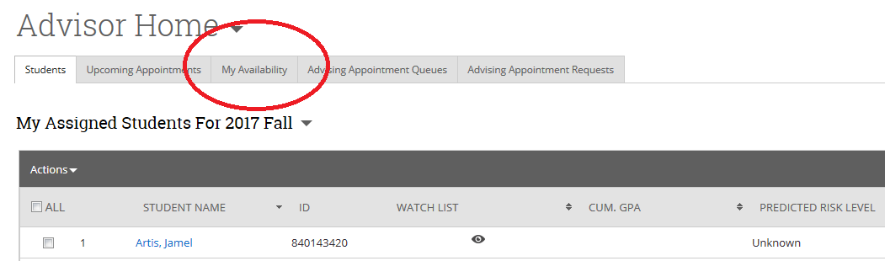

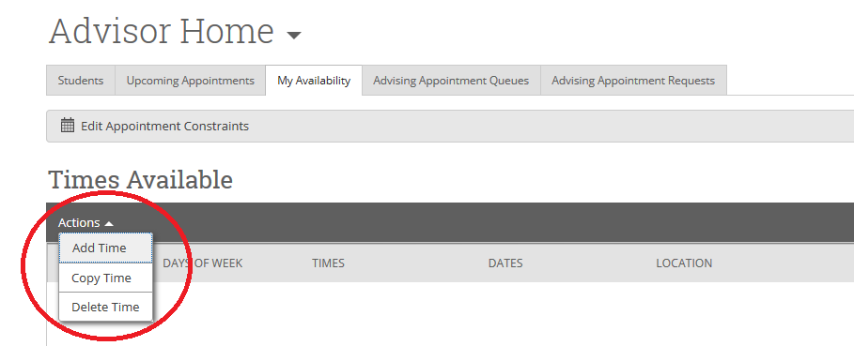
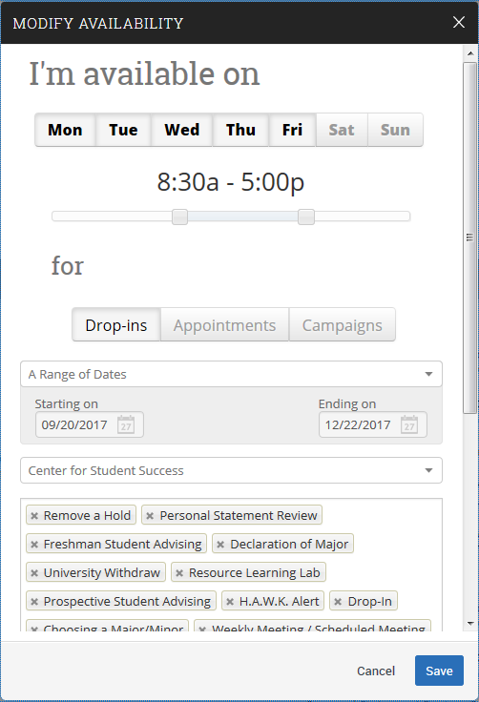
Availability
1. Select Available Days
2. Select Hourly Availability
3. Select ‘Drop-In’, ‘Appointments’ or ‘Campaigns’
4. Select Location
5. Select ‘All’ applicable services
6. ‘Save’

*NOTE*: Once you have created an ‘availability’ (i.e. ‘Drop-In’), you can select ‘Copy Time’ under the ‘Actions’ drop-down to mirror your selections for an alternate appointment type.

“Appointments and Appointment Campaigns”

1. ‘Select the students you want to message’

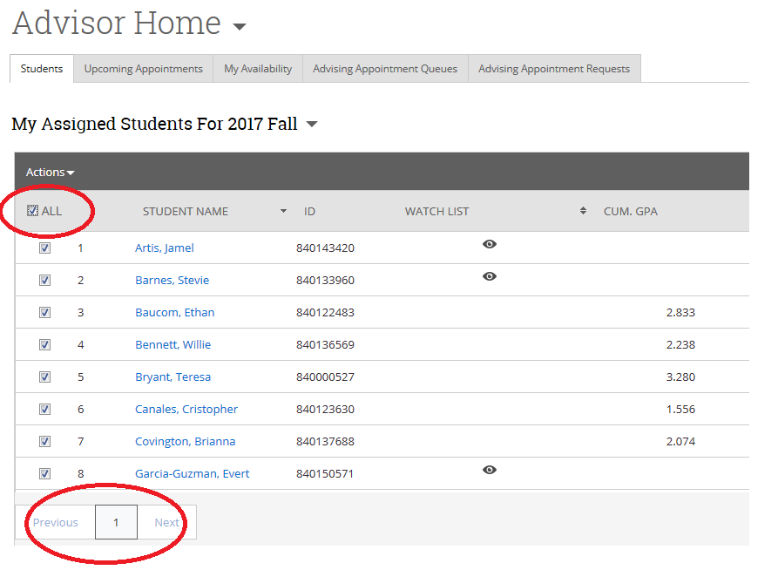

2. Select message preference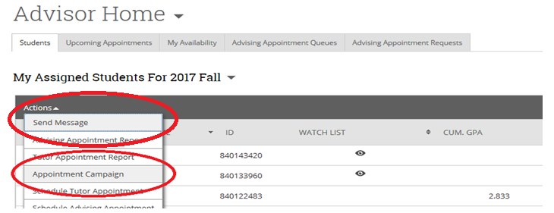
A. ‘Send a Message’
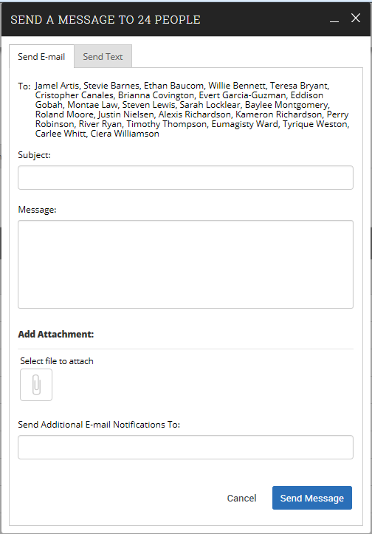

B. ‘Create Appointment Campaign’
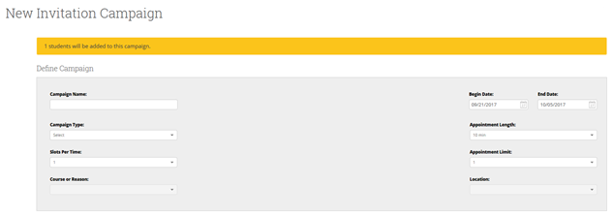
1. Name your ‘Campaign’
2. Select ‘Campaign Type’, ‘Slots Per Time’, ‘Course or Reason’, ‘Begin/End Date’, ‘Appointment Length/Limit’

...Review your Students
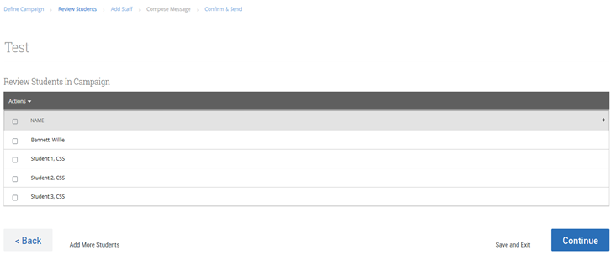

...Select your Advisors
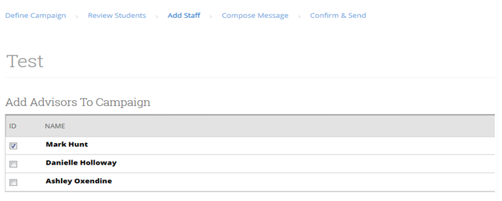
...Compose your Message or Keep the Preloaded Message
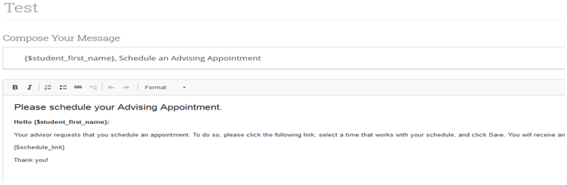
...Confirm and Send
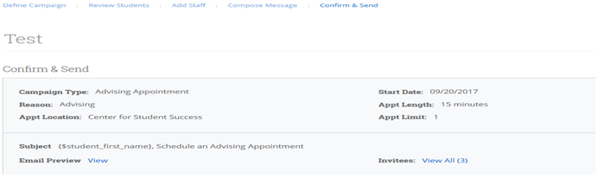
...Confirmation
“Advisor Reports”
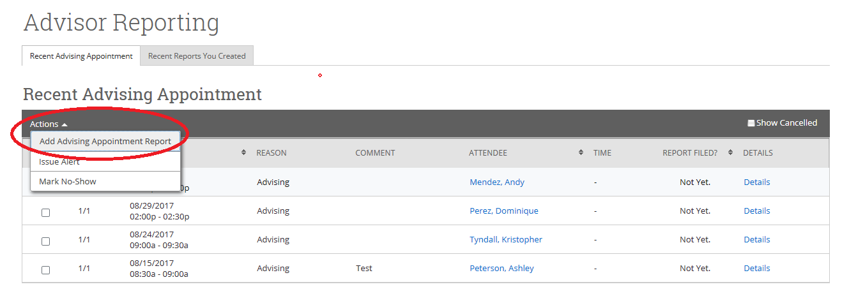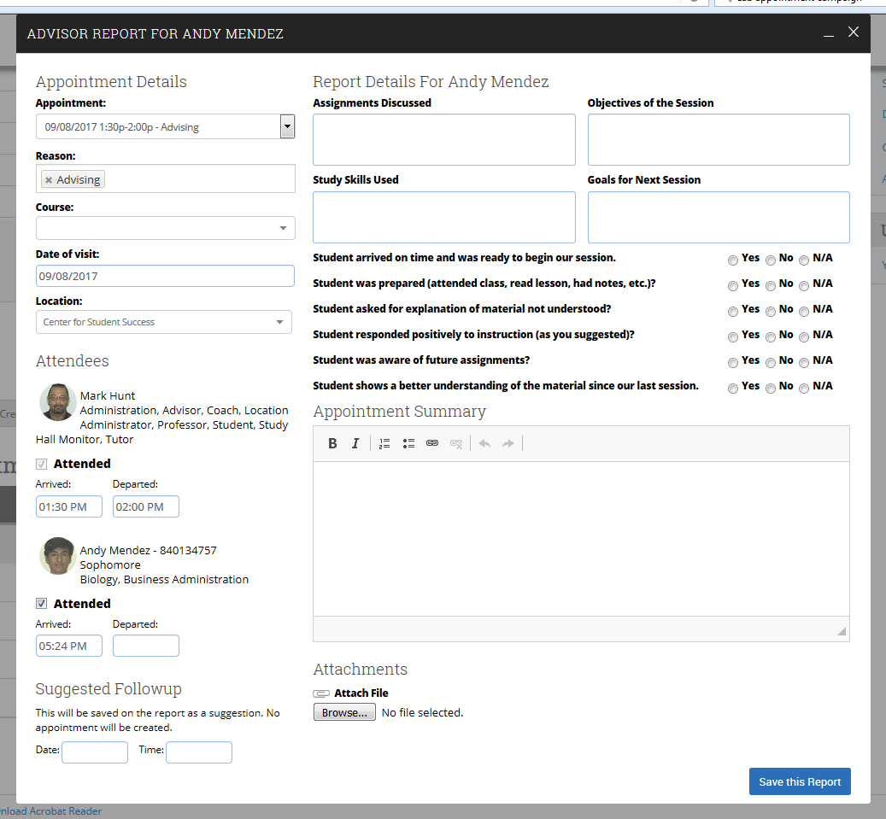
“Messaging”

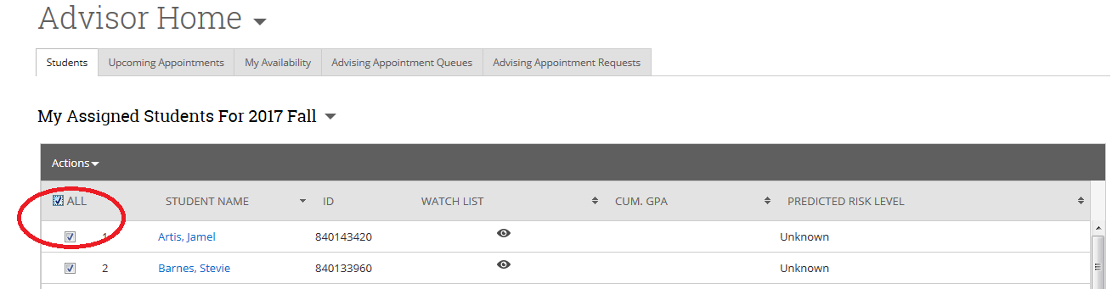

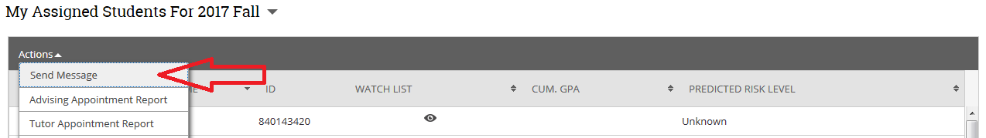

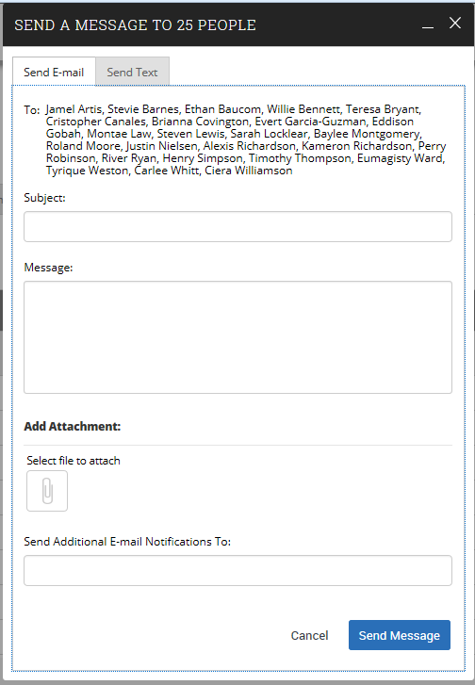
“Student Profile”

Tabs (Advisor Home Screen):

Overview (30 Sec. Gut Check)

Success Progress

History

Class Info

Major Explorer

More: Calendar, Study Hall, Appointments, Conversations

